# Projekt: Visualisierung der Grundstückspreise in Niederösterreich



Abbildung 1: visualization on my whiteboard

**20.09.2020:**

**I’ve come to the decision that, in order to help a friend of mine who is planning to purchase some property, I want to visualize the following data with the help of Python (Pandas), PowerBi and maybe also Tableau.**

**The data should consist of the median price per square meter of land per town/city and should also show how family-friendly the town is.**

**To do so, I downloaded the following Data:**

* **Price per square meter for Lower Austrian disctricts from here:**
  + [**https://www.bodenpreise.at/Home/List**](https://www.bodenpreise.at/Home/List)
* **Data on Kindergarten-Facilities in Lower Austria:**
  + [**https://www.data.gv.at/katalog/dataset/692e6b08-f8c3-4d1b-98b0-819a65549f07**](https://www.data.gv.at/katalog/dataset/692e6b08-f8c3-4d1b-98b0-819a65549f07)
* **Data on Schools in Lower Austria:**
  + [**https://www.data.gv.at/katalog/dataset/5624ab32-c91c-4db1-83f5-0f5eca8a1bcd**](https://www.data.gv.at/katalog/dataset/5624ab32-c91c-4db1-83f5-0f5eca8a1bcd)
* **Data on Playgrounds in Lower Austria:**
  + [**https://www.data.gv.at/katalog/dataset/8d72f56e-c5ec-4160-bf66-ed8d5dc6b60a**](https://www.data.gv.at/katalog/dataset/8d72f56e-c5ec-4160-bf66-ed8d5dc6b60a)

**Now it’s time to work with the data. Firstly, I had to put the data on price per square meter per town, which was formatted as xlsx, and saved as separate xlsx-files (one per political district), together into one big file.**

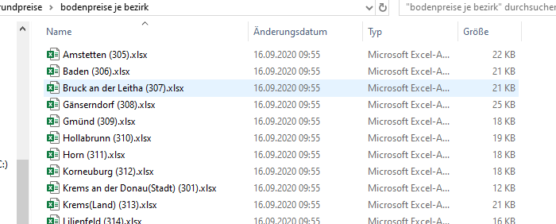

**To merge it into one big xlsx-File I did a little Work with pandas. It can be found in ‘bodenpreise.ipynb’**

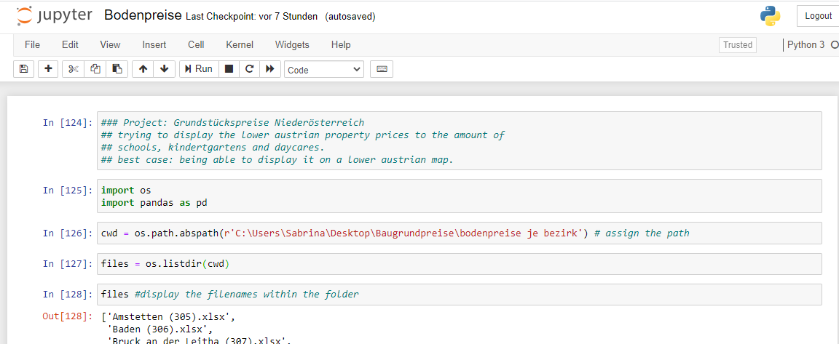

**To work with it later in the project, I decided to stick with the xlsx-Format.**

**The exported file is called ‘bodenpreise_noe.xlsx’.**

**For further work I decided to go with Power BI.**

**22.09.2020:**

**In order to be able to display our data in the shape of a map later on (which makes sense, since we’re dealing with geographical data) I collected the latitude and longitude from the google maps geocoding API:**

[**https://developers.google.com/maps/documentation/geocoding/overview**](https://developers.google.com/maps/documentation/geocoding/overview)

**I did this by writing a little script in jupyter notebook again – it’s the file ‘Baugrund_2.ipynb’**

**It’s output file is called ‘bodenpreise_noe_koord.xlsx’.**

**It’ll be the file with which we’ll keep on working.**

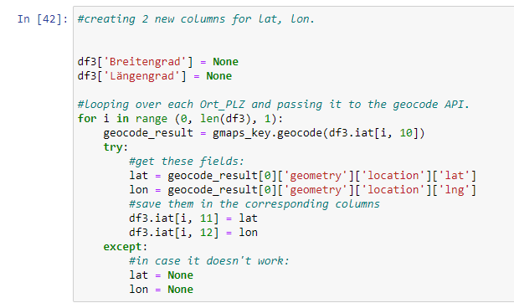

**I imported all the needed files and cleaned them up where necessary via the query editor, the kindergarten file for example had some messy lines on top of the sheet:**

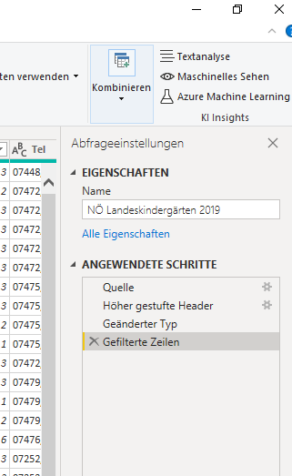

**That’s how I ended up with all the tables in Power BI like this where I wanted to connect all of them by setting up primary keys and relationships:**

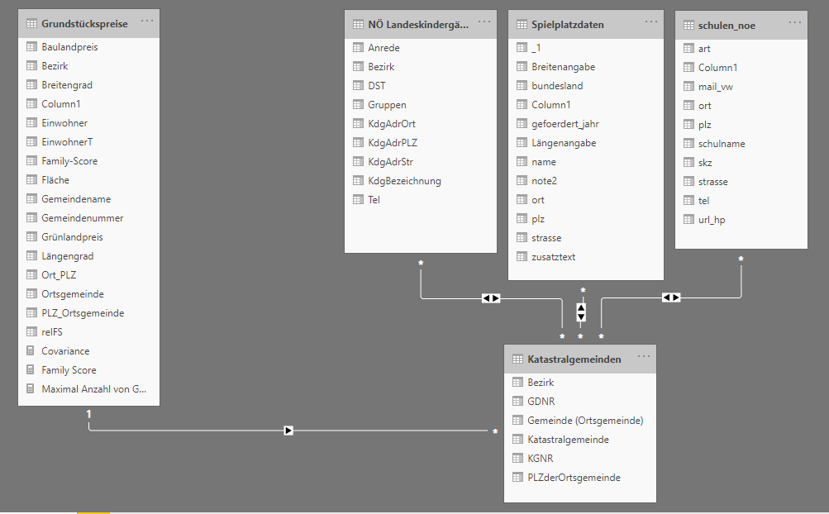

After a little more wrangling, sorting and cleaning of the data I was finally able to create my report.

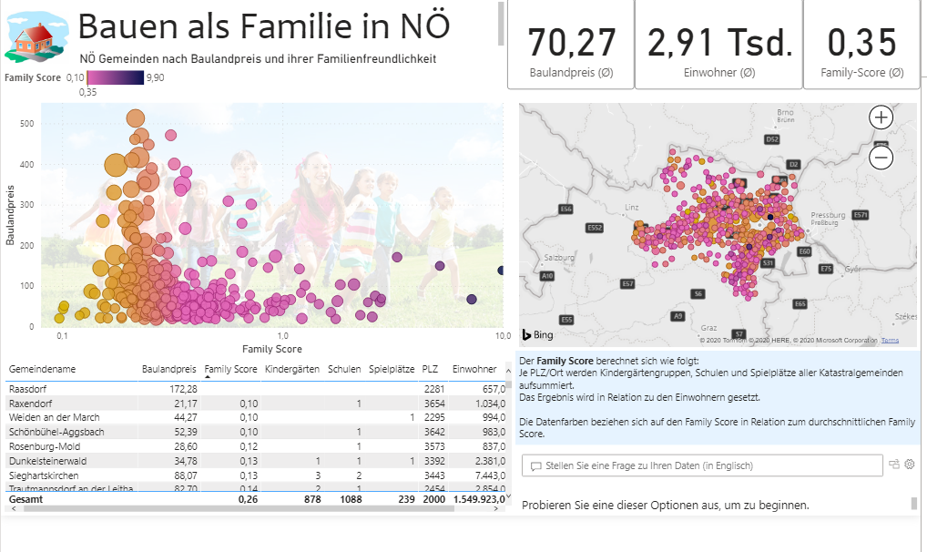

1. Icon
2. Title
3. Cards with quick infos on the average property price, Inhabitants and Family Score
4. Main Scatter graph: Family Score vs Baulandpreis (coloring: family Score, size: EinwohnerT)
5. Map of lower Austria with bubbles for each Gemeinde (coloring & size same as 4)
6. Table with more detailed info
7. Explanation of the family score which I calculated as a measure.
8. Q&A Section where you can enter an English question and power bi gives you the desired info.

Of course, I didn’t forget about mobile users either:

